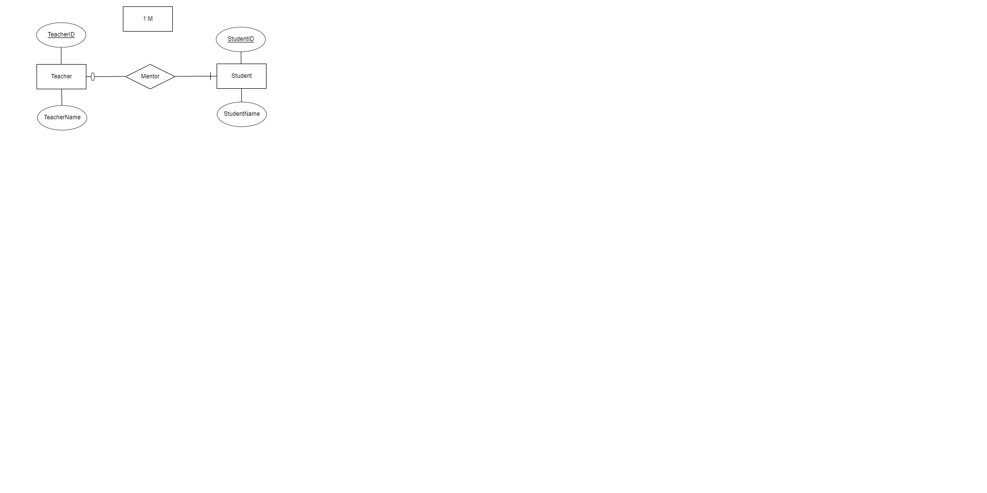Assignment 5

**E.2.2a –**

A teacher can lecture many students, and a student can only have one teacher as the mentor. Furthermore, a teacher may not have any students as the mentor, but a student must need a teacher as

the mentor.

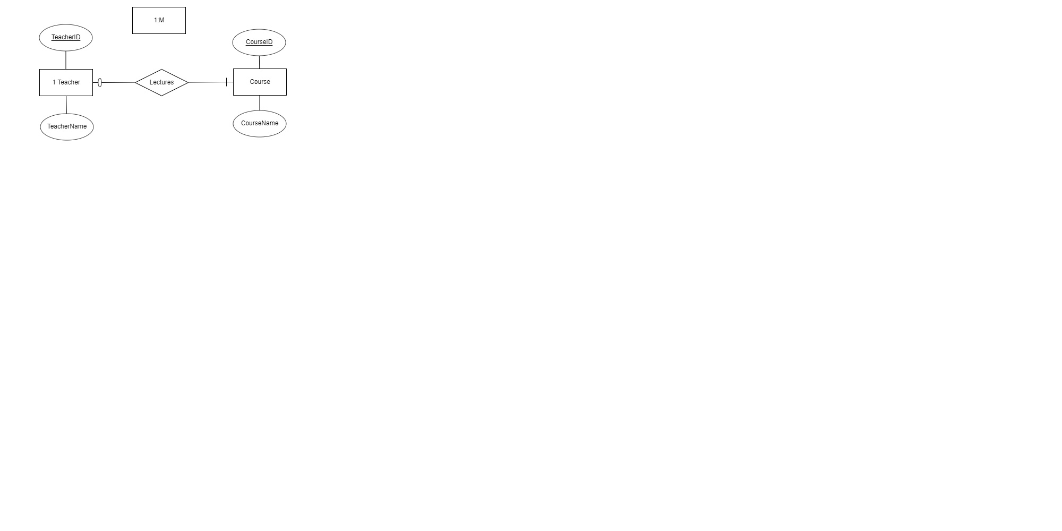

**E.2.2b –**

A teacher can lecture a course, but a course can have more than one teacher as the lecturer. Furthermore, a teacher may have any courses as the lecturer, but a course must need a teacher as

the lecturer.

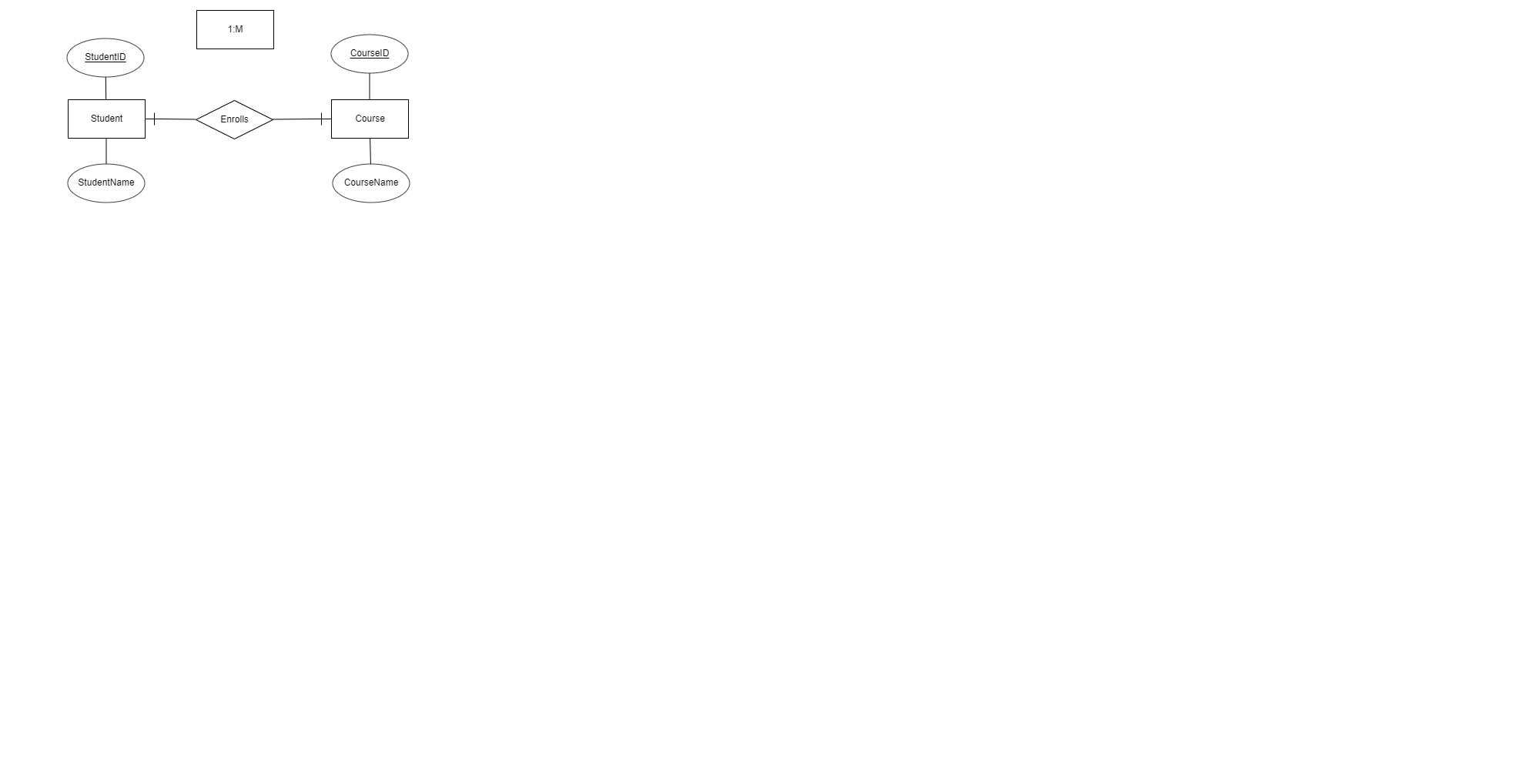**E.2.2c –**

A student can enroll in a course, a course can have more than one student that enrolls. Furthermore, a student must enroll in a course and a course must need students to enroll in.

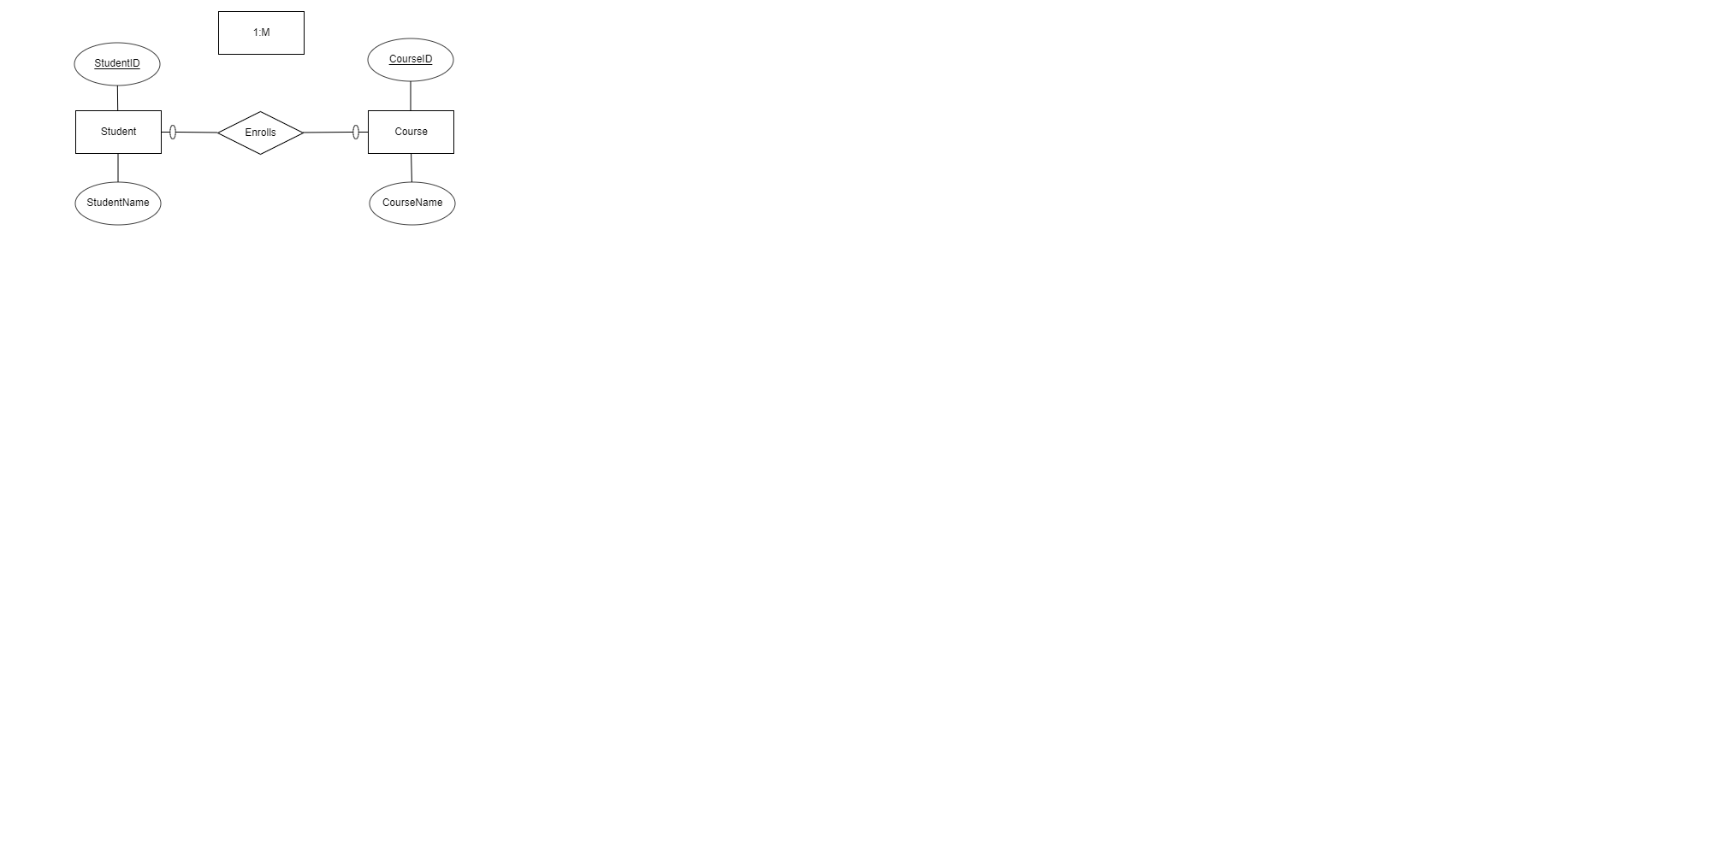**E.2.2d –**

A student does not have to enroll in a course, and a course doesn’t have to have students that enroll.

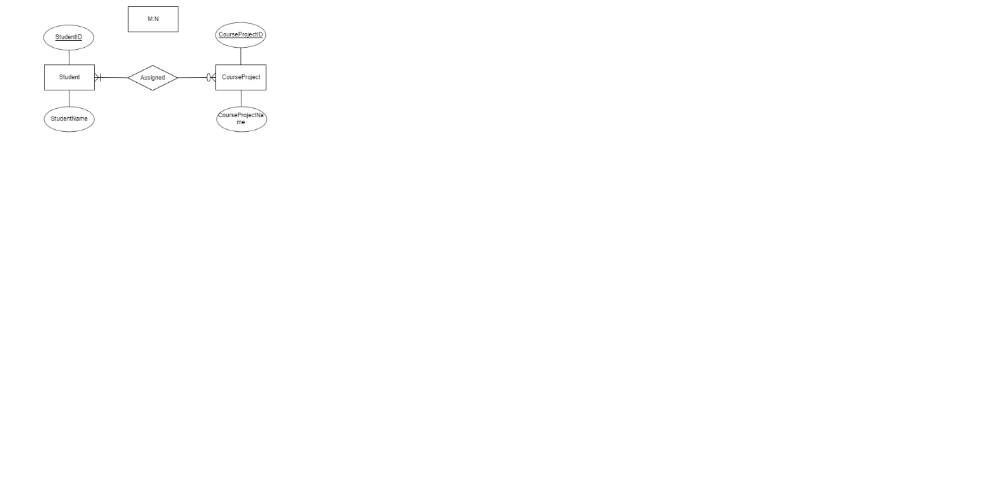**E.2.2e –**

Many students are assigned mandatory course projects, it is optional to assign many course projects to many students. The many students need assigned course projects while course projects do not need to be assigned to many students.

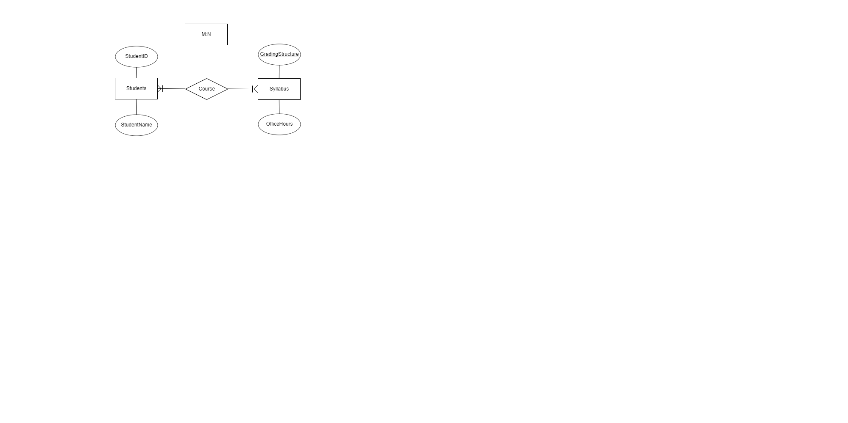

**E.2.2f –**

Many students are mandatory to have a course with a syllabus, many syllabi are mandatory to have a course and many students.

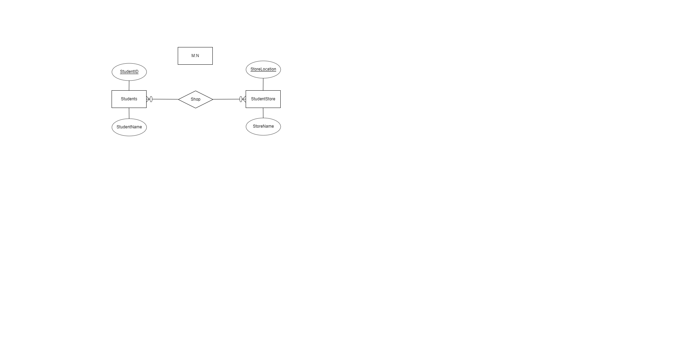**E.2.2g –**

It is optional for many students to shop at the student store, and it is optional to have only many students shopping at the student store.